**Wisconsin Farm Bureau Federation**

**County Activities of Excellence 2016**

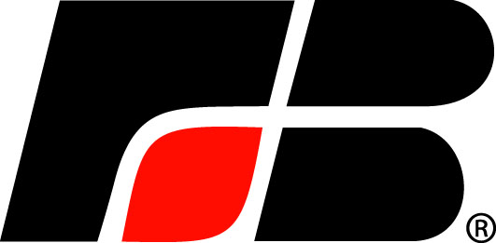

***Motivating Action…Celebrating Success***

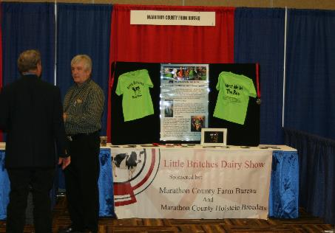

Farm Bureau is a grassroots organization whose effectiveness is the result of innovative, action-oriented programs developed by county Farm Bureaus. The County Activities of Excellence (CAE) Program is designed to celebrate and recognize such programs. The purpose of the program is to recognize outstanding county Farm Bureau programs and share successful programs and activities.

The County Activities of Excellence Program focuses on the priority issues of the organization, seeking county applications in the categories of: Legislative Accomplishments, Local Affairs, Ag Promotion & Education, Leadership Development, Membership Recruitment & Retention, Member Services & Communication, Young Farmer & Agriculturist (YFA) Program, and Special Programs.

Eight outstanding county programs will be selected to display their winning program/activity during the WFBF 97th Annual Meeting Trade Show on December 3-4 at the Kalahari Resort in Wisconsin Dells. Those counties with a winning entry will receive $500 toward expenses to participate in the WFBF Annual Meeting Trade Show. Complimentary exhibit space will be provided for county Farm Bureau programs selected as *Activities of Excellence*.

Enter your county’s outstanding program and you may be showing it to Farm Bureau members from across the state in December!

***The eight program categories are:***

1. Legislative Accomplishments
2. Local Affairs
3. Ag Promotion & Education
4. Leadership Development
5. Membership Recruitment & Retention
6. Member Services & Communication
7. Young Farmer & Agriculturist (YFA) Program
8. Special Program

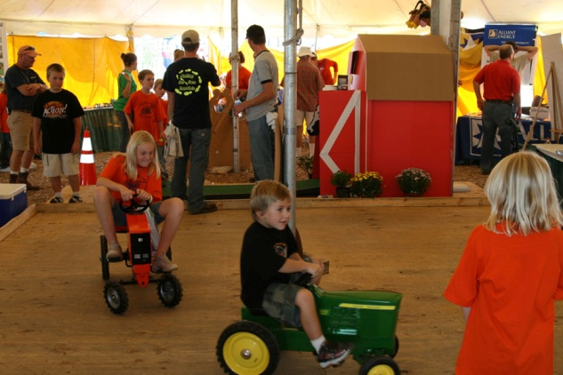

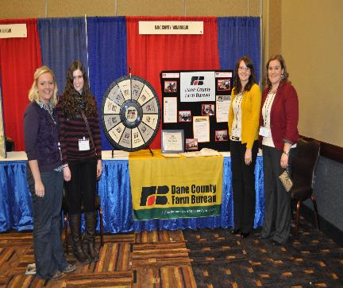

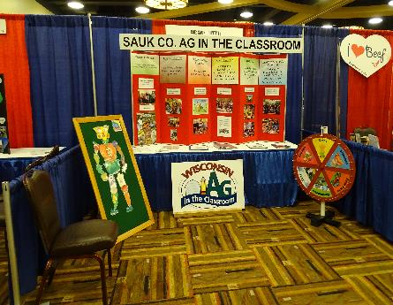

**Submit your entry today and tell Farm Bureau members from across the state about your county’s successful program or activity!**

***Program Rules and Guidelines***

1. County Farm Bureau applications must be received at the WFBF office no later than August 31, 2016. Applications can be downloaded at [www.wfbf.com](http://www.wfbf.com).
2. No photos or additional materials will be accepted. Entry forms must be complete and shall be no more than two pages long, not including the entry form information sheet. Computer generated applications must use a minimum 10 point Arial or Times New Roman font.
3. A county may submit an entry for each program category, however, no more than two (2) entries will be selected for recognition from an individual county at the WFBF Annual Meeting Trade Show. ***See following page for guidelines on program categories and corresponding activities.***
4. County Farm Bureau should submit a copy of the entry form for each program area for which an entry is being submitted, either in hardcopy or electronically. Entry forms submitted by the deadline will be reviewed by a panel of judges and evaluated solely on the contents of the entry form. Any activity for which an entry is submitted should have taken place during the period from July 31, 2015 to August 1, 2016.

1. Only those entry forms which are approved by the county Farm Bureau president will be accepted.
2. By submitting an entry, county Farm Bureaus agree to showcase the program or activity (if selected as a CAE winner) with an exhibit at the WFBF Annual Meeting trade show.
3. WFBF will announce those counties selected to participate at the 2016 annual meeting trade show by October 15, 2016.
4. County Farm Bureaus submitting the eight winning programs selected to display at the 2016 WFBF Annual Meeting will receive a cash award of $500 to be applied toward the costs of travel and exhibiting at the WFBF Annual Meeting. The cash awards will be presented following the annual meeting only if the county Farm Bureau exhibits at the annual meeting.
5. The county Farm Bureaus selected by WFBF will be responsible for preparing and delivering the exhibit materials to the WFBF annual meeting and for setting up, staffing and dismantling the display at the annual meeting trade show in Wisconsin Dells on December 3-4, 2016.
6. WFBF staff will not be involved in preparing county entries, judging entries or preparing displays/exhibits for winning entries.
7. County Farm Bureaus with programs that were selected as winners at the 2015 WFBF Annual Meeting are ineligible to enter in the same category in 2016. Those selected as winners in 2016 will be ineligible to enter in the same category in 2017.

**Submit your entry today and tell Farm Bureau members from across the state about your county’s successful program or activity!**

***CAE Program Categories***

Below are the eight CAE categories and suggested activities to be included under each:

* 1. **Legislative Accomplishments**

Entries submitted for this category may include, but are not limited to: county Farm Bureau-sponsored meetings/events with state and national lawmakers or their staffs to discuss issues; letter-writing, e-mail and telephone campaigns to state and national lawmakers in response to action requests; county Farm Bureau’s work on a specific legislative issue or problem; work the county has done to communicate legislative issues to members and gather their input.

* 1. **Local Affairs**

Entries submitted for this category may include, but are not limited to: County Farm Bureau-sponsored meetings/events with local officials (county board, town board, school boards, local government agency representatives); letter-writing, e-mail and telephone campaigns to local officials regarding issues; work the county has done to communicate local issues to members and gather their input.

* 1. **Ag Promotion & Education**

Entries submitted for this category may include, but are not limited to: Agriculture in the Classroom activities such as hosting farm tours, conducting Farmer in the Classroom events, holding teacher training events, or distributing AITC resources; conducting commodity promotion events such as breakfast on the farm; consumer education events; agricultural presentations to service clubs & civic organizations; Farm-City/Rural-Urban events.

* 1. **Leadership Development**

Entries submitted for this category may include, but are not limited to: providing training opportunities to help Farm Bureau members develop leadership skills; sponsoring or promoting county youth and/or adult participation in leadership development events.

* 1. **Membership Recruitment & Retention**

Entries submitted for this category may include, but are not limited to: planning and conducting successful and unique or innovative membership recruitment/retention campaigns, utilizing existing Farm Bureau programs or events to build Farm Bureau membership.

* 1. **Member Services & Communication**

Entries submitted for this category may include, but are not limited to: unique or innovative programs or services provided to county Farm Bureau members; member contact program; promotion of member benefits and services to members.

* 1. **Young Farmer & Agriculturist (YFA) Program**

Entries submitted for this category may include, but are not limited to: events or activities that are conducted by the county Farm Bureau YFA Committee to promote agriculture, youth education, consumer education, and/or promote involvement and leadership opportunities for YFA’s in Farm Bureau.

* 1. **Special Program**

Entries submitted for this category should include any program or project that does not fit into one of the above categories.

*ENTRY FORM*

*INFORMATION SHEET*

* *Forms must be received by WFBF no later than August 31, 2016.*
* *Announcement of winners will be made no later than October 15, 2016.*

Entries are limited to two single-sided pages, not including this page.

County Farm Bureau: ________________________________

Name of person completing this form: ________________________________

Person to contact if this entry is selected by judges as a winner:

Name: _______________________________

Address: _______________________________

Phone: _______________________________

E-mail: _______________________________

___________________________________ ____________

Signature of County Farm Bureau President Date

**Submit completed and signed entry to:**

**County Activities of Excellence Program**

**Wisconsin Farm Bureau Federation**

**P.O. Box 5550**

**Madison, WI 53705-0550**

**Wisconsin Farm Bureau Federation**

**County Activities of Excellence 2016**



1. Title of Activity: ________________________________________________________

1. Enter Program Category: (check only one)

___ Legislative Accomplishments ___ Leadership Development

___ Ag Promotion & Education ___ Member Services & Communication

___ Membership Recruitment & Retention ___ Young Farmer & Agriculturist Program

___ Local Affairs ___ Special Program

3. Please provide a brief summary of the activity: (not to exceed 100 words)

1. Please provide a brief response for each of the following:
   * + 1. 1. Briefly state the purpose of the activity. A) What is the goal of the program or activity? B) How does it relate to the overall goals of the organization? C) What are the desired outcomes as a result of your county conducting this activity? (20 points)
       2. Describe the program, keeping in mind that the judges have not seen or participated in the activity. (20 points)

**Wisconsin Farm Bureau Federation**

**County Activities of Excellence 2016**



3. What were your objectives for the program or activity? What did you want to accomplish? Who was the target audience? How did you plan and promote the program or activity? (20 points)

4. What were the results of the activity? Please include number of FB volunteers involved in carrying out the activity and the number people reached through this activity. How did this program or activity provide a service to Farm Bureau members or the general public? (40 points)