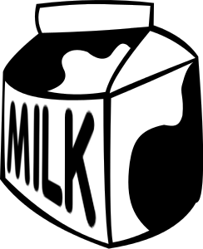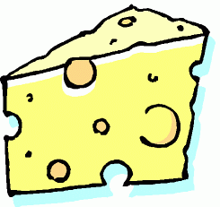
Jefferson County Dairy Promotion Funding Application
The Jefferson County Farm Bureau administers funding for Jefferson County area 4-H, FFA, dairy farms or others to conduct promotional events in support of the dairy industry.
Jefferson County Farm Bureau receives support from the Wisconsin Milk Marketing Board to help promote the dairy industry. The funding cycle is open year-round from January 1-December 31 for promoting dairy in Jefferson County, but, funds are awarded on a first come, first served basis.
Promotional events must focus on at least one of the following criteria:
Enhancing the awareness of the nutritional and health benefits from dairy products
Increase knowledge of the dairy industry
Advance the image of the dairy industry and public trust
Individuals, groups or organizations may submit multiple applications toward the purchase of dairy products and Wisconsin Milk Marketing Board promotional items.
Dairy promotion money CANNOT be used to purchase items for resale or to be used at profit-generating or political events.
Eligibility
Applicants must be from Jefferson County.
Applicants must submit at least two event photos from their event of participants receiving or eating dairy products.
Selection Process
Eligible applications will be reviewed and awarded on a first-come first serve basis.
Applicants will receive an email or written notification regarding approval within 10-15 business days of when the application was submitted.
Reimbursement Process
The request for dairy promotion reimbursement must be submitted within 30 days following the scheduled promotional event.
Farm Bureau will issue payment within 30 days of receiving original receipts and two photos.

Return this form to:
Jefferson County Dairy Funding
C/O Melissa Gross
1523 Radhika St.
Fort Atkinson, WI 53538
mgross43@yahoo.com

Name of individual, group or organization_____________________________________________________________
Address_________________________________________________________________________________________
Primary phone number______________________ email address_________________________________________
Event title_______________________________________________________________________________________
Event date________________________________
Event description _________________________________________________________________________________________
_________________________________________________________________________________________________________
_________________________________________________________________________________________________________
Event objective __________________________________________________________________________________________
_________________________________________________________________________________________________________
_________________________________________________________________________________________________________
Event activities ___________________________________________________________________________________________
_________________________________________________________________________________________________________
_________________________________________________________________________________________________________
How will the grant funds be used? __________________________________________________________________________
_________________________________________________________________________________________________________
_________________________________________________________________________________________________________
What dairy items to be served? ______________________________________________________________________
_________________________________________________________________________________________________________
Funding request $____________________
List additional funding support (if applicable) ___________________________________________________________

For office use only
Date approved Amount approved
Approved by board action or name of board officer
Comments
Form Date 4/01/14

