Wisconsin Farm Bureau Foundation Euchre Tournament Rules

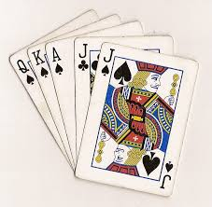
Format: Each table will be numbered, and players will
rotate and change partners after each round.
The tournament will consist of six rounds, with
eight hands played in each round. Each player
at the table will deal twice per round.

When the round ends, players will record their
scores and the winning team will move to the
next lower numbered table (Winners at table 8 move to table 7, winners
at table 7 move to table 6, etc. Winners at table 1 will move to highest numbered table). If there is a tie score at the end of the round, each team draws one card and the team with the higher number moves to the next table. Both the winning and losing teams will change partners after each round. Before moving, all players will cut cards to determine a “high” and a “low” for each team. At the next table the two “highs” are partners and the two “lows” are partners.

Dealing: The “high” player that has moved to the new table begins the deal and the deal passes to the left after each hand. If no trump is named, the dealer will deal again.

Scoring: Three tricks = one point
Five tricks = two points
“Euchre” or “Set” = two points
Lone Hand = four points

A numbered “table” scoresheet will be provided at each table to track scoring as the round proceeds. Each player will track their own cumulative score from each round using the “personal” scoresheet provided when they register. At the conclusion of six rounds, all players’ scores will be tallied, and prizes will be awarded to the top three scoring players.

Sit-Out: If the number of players is not a multiple of four, players moving from table 1 to the highest numbered table will “sit-out” for a round and re-enter the game at the highest numbered table for the following round. Players who “sit-out” will receive a score of 7 for that round.

