INDIVIDUAL KALAHARI RESORT ROOM RESERVATIONS

Call 1-877-253-5466

Be sure to ask for the “Wisconsin Farm Bureau Federation” block of rooms

December 6-9, 2019

Cut-off date for reservations is October 25th
Rooms are limited and will sell out quickly – reserve early!!

- All reservations require a one-night (plus tax) deposit for each room reserved at the time the reservation is made
  - No personal checks accepted for deposit or check-in
  - Your credit card will be charged at the time of reservation for one-night deposit for each room reserved
- Reservations cancelled 72 hours or more in advance of arrival will receive a full refund less a $25 processing fee
- Cancellations less than 72 hours prior to arrival will forfeit the entire deposit
- An “early check out” fee of one night room and tax will be charged for departing before your arranged departure date

Hotel registration starts at Noon. This will enable you to receive your waterpark passes.
You may or may not be able to actually check into your room at that time.

More Room Options on Reverse Side
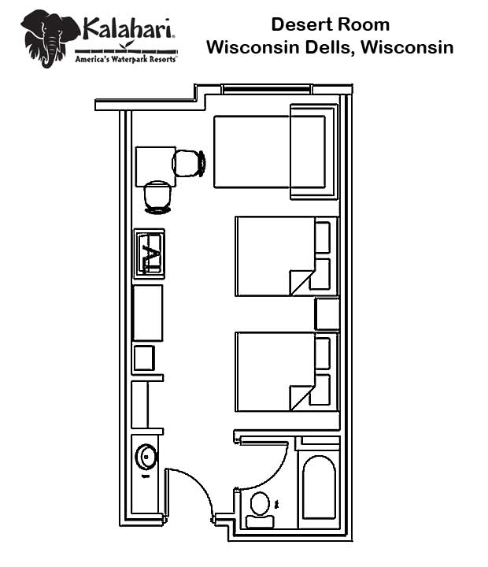
Cost: $114/night plus 12.25% tax ($127.97)
Two queen beds / full size sofa sleeper
Sleeps 4 people
** Up to two additional guests may be added for $50/person per night
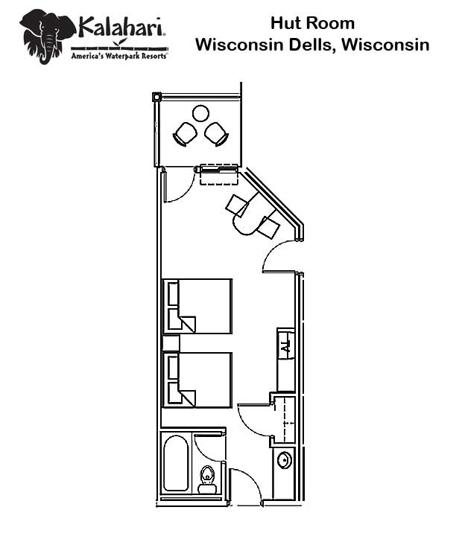
Cost: $114/night plus 12.25% tax ($127.97)
Two queen beds / Work desk
Sleeps 4 people

www.kalahariresorts.com
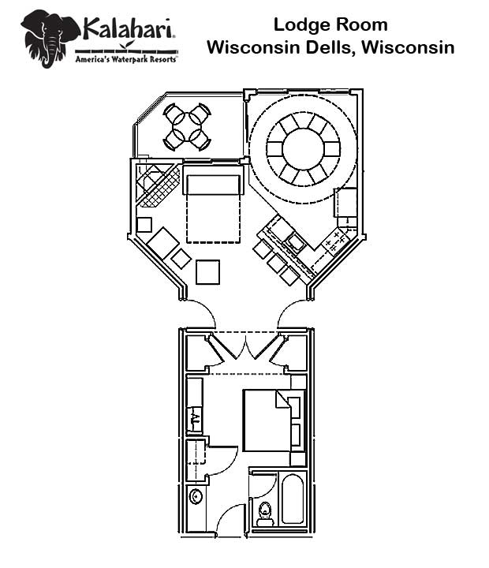
Cost: $139 plus 12.25% tax ($156.03)
One king bed plus one queen size sofa sleeper
Sleeps 4 people

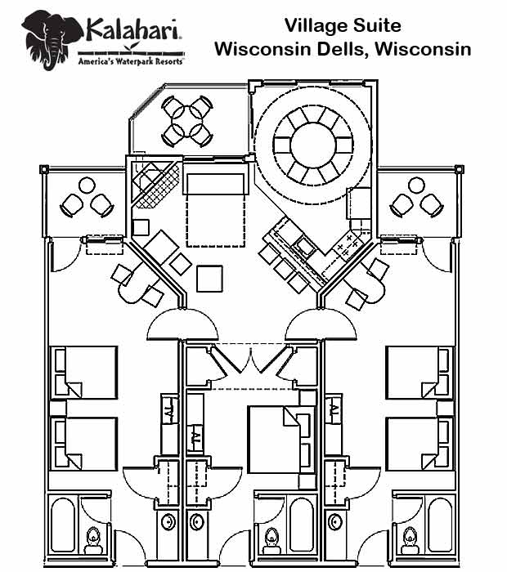

Cost: $367/night plus 12.25% tax ($411.96)
Three bedrooms; one with king bed and two with two queen beds /
queen size sofa sleeper in living room
Sleeps 12 people
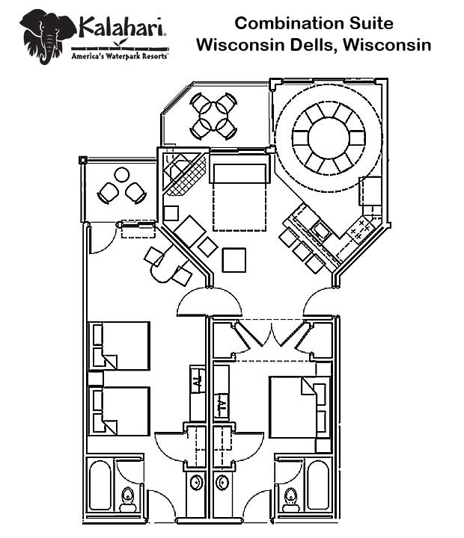
Cost: $253 plus 12.25% tax ($283.99)
Two bedrooms; one with king bed and one with two queen beds / queen size sofa sleeper in living room
Sleeps 8 people

