Rusk County Farm Bureau®

Walter Stanger Scholarship Application Form

Re: Rusk County Farm Bureau Walter Stanger Agriculture Scholarships Intent to Award

The Rusk County Farm Bureau is pleased to announce their intent to award a higher education scholarship/scholarships for graduating high school seniors in the amount of $250.00.* The scholarship/scholarships are open to all graduating seniors living in Rusk County and accepted into an accredited Agriculture related field of study through college, vocation or technical school. Preference will be given to students of Farm Bureau families, but all applicants will be seriously considered and encouraged to apply.

The Agriculture scholarship/scholarships will be based on the student’s past school history, community activities, acceptance into an accredited program, recommendations and a fully completed application submitted by the student.

*Any amounts over and above the $250.00 and number of scholarships will be based on the completed submissions and upcoming fund-raising activities by Rusk County Farm Bureau. *

Please send back the enclosed application along with all requirements to either of the individuals below. Also, students should enclose a photo of themselves to be used for publication purposes. (Please utilize the enclosed checklist to be certain your submission is complete).

Scholarship applications should be postmarked by April 1, 2020 and sent to:

Paul Hetke
N4416 Cloverland Rd
Ladysmith WI 54848
cloverkeyfarm@yahoo.com

We will present a certificate of scholarship to the winning student/students upon award. The scholarship funds will be awarded after the student has completed one session of a fully accredited college, technical/ vocational school semester and has provided Rusk County Farm Bureau with a transcript and grades showing at least a 2.5 grade point average in their Agriculture related program.

Please find attached the application and specific details in this announcement.

Sincerely,

Rusk County Farm Bureau Rusk County Wisconsin

Rusk County Farm Bureau Walter Stanger Agriculture Scholarships Available

Wally Stanger pictured below along with his wife Kathleen was never seen without a big smile on his face. He was a Rusk County Farm Bureau Director, he was on the Rusk County Jr. Fair Board of Directors and he was continuously involved with the Milk Producers. He put on the Rusk County Dairy Breakfast each year. He worked very hard to involve the young people of Rusk County Wisconsin in Agriculture. He was famous around Wisconsin for his pedal tractor pulls. He loved his family and doing work in his community. He worked hard as a dairy farmer to support Agriculture and Community activities in Rusk County. This scholarship will be awarded by the Rusk County Farm Bureau in Wally Stanger’s name.
Farming and Agriculture is a proud Wisconsin Tradition and Rusk County Farm Bureau would like to support young farmers.
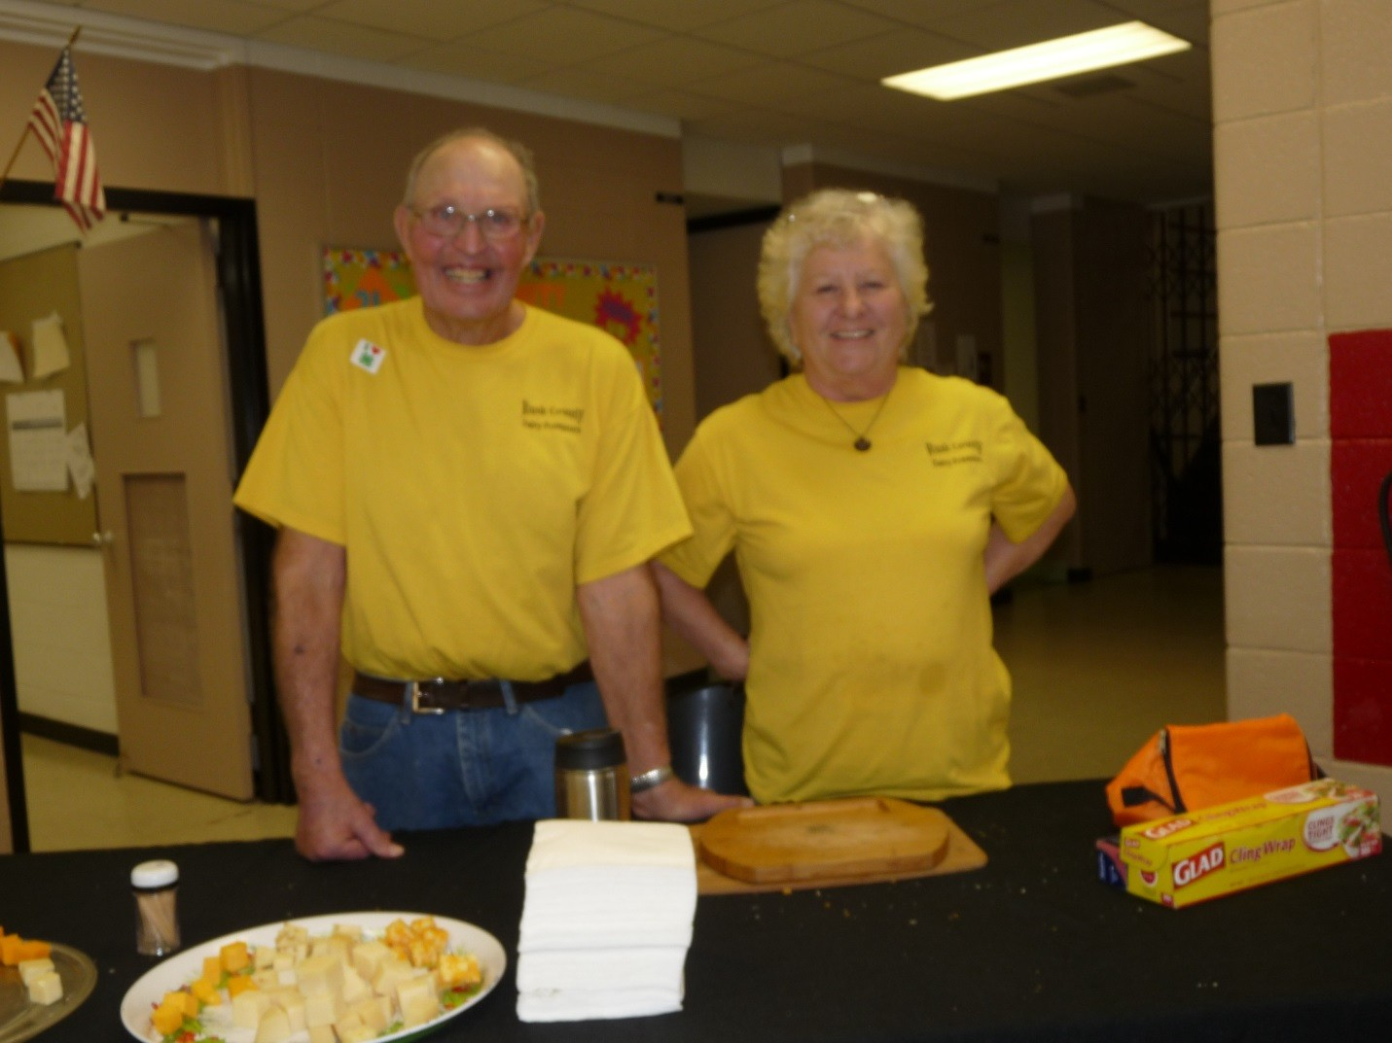
Rusk County Farm Bureau®

Walter Stanger Scholarship Application Form

Name Click or tap here to enter text. Date of Birth Click or tap here to enter text.

Home Mailing Address Click or tap here to enter text.
Click or tap here to enter text.

Name of Parent(s)/Guardian Click or tap here to enter text.

Name of High School Click or tap here to enter text.
Year of Graduation Click or tap here to enter text.
What is your current Class Rank? Click or tap here to enter text.
What is your current GPA? Click or tap here to enter text.
What is your current SAT or ACT Score? Click or tap here to enter text.

College or Technical/Vocational School Attending Click or tap here to enter text.
Have you been accepted? ☐Yes ☐No

Indicate your intended major or general field of study Click or tap here to enter text.

Please list your school activities and awards:
Click or tap here to enter text.

List other community activities and awards (Include church, 4-H, etc.):
Click or tap here to enter text.

What skills and knowledge have you gained through past work experience? How you
plan to utilize them in the future?
Click or tap here to enter text.

Explain why you have chosen your major and what goals you have set for your future?
Click or tap here to enter text.

Why do you feel you deserve this scholarship and what impact has Agriculture had on your life?
Click or tap here to enter text.

To verify applicants Farm Bureau member status, please indicate the name of the individual holding current Farm Bureau membership:

Member Name Click or tap here to enter text.

Applicant’s Relationship to Member (Son/Daughter/Self) Click or tap here to enter text.

List the two individuals from whom you have requested recommendations:

Name: Click or tap here to enter text. Name: Click or tap here to enter text.
Company: Click or tap here to enter text. Company: Click or tap here to enter text.
Address: Click or tap here to enter text. Address: Click or tap here to enter text.
Phone: Click or tap here to enter text. Phone: Click or tap here to enter text.

Applicant’s Signature Date

Phone Click or tap here to enter text.

Student Scholarship Checklist before mailing:

- Application Form typed or printed so it can easily be read by Judges.
- Application Form fully completed.
- Complete Contact Information for your references.
- Picture of the student that will not be returned and will be used for promotional purposes.
- Attach a one-page letter from your Ag Instructor or a Teacher sponsoring you for this scholarship.
- Be as detailed as possible and answer the questions directly.
- Any last-minute questions please feel free to contact Katie Mattison, 715.418.0975

*Please note Rusk County Farm Bureau reserves the right to accept or reject any submissions or make modifications to our award based on the submissions received.

