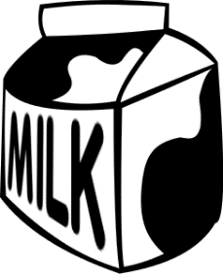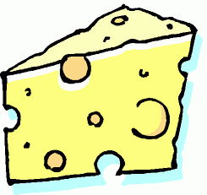
Jefferson County Dairy Promotion Funding Application
The Jefferson County Farm Bureau administers funding for Jefferson County area 4-H, FFA, dairy farms or others to conduct promotional events in support of the dairy industry.
Jefferson County Farm Bureau receives support from Dairy Farmers of Wisconsin to help promote the dairy industry. The funding cycle is open year-round from January 1-December 31 for promoting dairy in Jefferson County. Funds are awarded on a first come, first served basis.
Promotional events must focus education on at least one of the following criteria:
• Dairy is Good for My Body
• Dairy is Good for My Community
• Dairy is Good for My Planet
• National Dairy Month
Individuals, groups or organizations may submit an application toward the purchase of Dairy Farmers of Wisconsin promotional items.
Dairy promotion money CANNOT be used to purchase items for resale or to be used at profit-generating or political events.
Eligibility
Applicants must be from Jefferson County.
Applicants must submit at least two event photos from their event or promotion and provide public recognition to Dairy Farmers of Wisconsin.
Selection Process
Eligible applications will be reviewed and awarded on a first-come first serve basis.
Applicants will receive an email or written notification regarding approval within 10-15 business days of when the application was submitted.
Reimbursement Process
The request for dairy promotion reimbursement must be submitted within 30 days following the scheduled promotional event. Farm Bureau will issue payment within 30 days of receiving original receipts, two photos and proof of public recognition given to Dairy Farmers of Wisconsin.

Return this form to:
Jefferson County Dairy Funding
C/O Melissa Gross
1523 Radhika St.
Fort Atkinson, WI 53538
mgross43@yahoo.com

Name of individual, group or organization:
Address:
Phone number: Email address:

Event/Promotion title:
Event/Promotion date(s):
1. Which educational component will this promotion focus on? • Dairy is Good for My Body • Dairy is Good for My Community • Dairy is Good for My Planet • National Dairy Month
2. Describe how the activity will be executed or implemented:

3. What makes this activity unique or how does it bring new focus to your dairy promotion?

4. Why do you feel that this will be a successful dairy promotion?

5. How will the grant funds be used?

6. Dollar amount requested?

List additional funding support (if applicable)

Revised Form Date 4/17/21

